Correlation of Behavioral and Demographic Factors in Florida Boating Accidents

Cristina Cuervo¹, Charlene Xia²

¹ Carrollton School of the Sacred Heart, Miami, Florida
² Massachusetts Institute of Technology (MIT), Cambridge, Massachusetts

Student Authors
Cristina Cuervo, High School

KEYWORDS: Boating Accidents, Operator Inattention, Operator Age, Boater Education

OVERVIEW: This study aimed to examine the relationship between operator inattention, operator age, and boater education in Florida boating accidents from 2015 to 2024. It specifically investigated whether operators aged 50 and older, particularly those without formal boating education, were more likely to be involved in accidents related to inattention or failure to maintain a proper look-out.

SUMMARY
We investigated the relationship between operator inattention, operator age, and boater education in boating accidents in Florida from 2015 to 2024. It involved analysis of annual statistical reports and incident records compiled by the Florida Fish and Wildlife Conservation Commission — including extraction and organization of data on accident frequency, contributing factors, operator demographics, and education levels — as well as trend analysis over time. Quantitative findings were supplemented by a semi-structured interview with a Florida Fish and Wildlife Conservation Commission lieutenant to clarify reporting procedures and observed patterns in boating incidents. It was found that operator inattention or failure to maintain a proper look-out was a leading and increasing contributing factor, accounting for a substantial proportion of accidents. Operators aged over 50 years represented the largest demographic group involved and consistently accounted for the highest number of individuals without formal boater education. Case study analysis further showed that accidents involving older operators frequently involved lapses in situational awareness, often in combination with factors such as excessive speed or alcohol use. These findings suggest that the interaction between operator age, lack of education, and inattention contributes to accident risk, and that targeted boater education and increased emphasis on maintaining operator attention may reduce preventable boating accidents.
INTRODUCTION
One of the popular recreational activities among the residents of the state of Florida is boating, which results in many deaths and injuries per annum. Florida is known to report the largest number of boat accidents in the entire nation, and therefore the problem of boating safety should be considered important for the state’s public health and maritime safety. The average number of deaths and injuries per year during the last ten years is 66 deaths and around 432 injuries (Florida Fish and Wildlife Conservation Commission, 2024). The estimated cost of these incidents is approximately $21.5 million in damages (Boating Lessons, n.d.).
Despite the frequency and severity of boating accidents, the underlying causes of these incidents are often less clearly defined than those of highway accidents involving land-based motor vehicles, where risk factors such as distracted driving and alcohol impairment have been extensively studied and widely communicated. Boating accidents frequently involve multiple interacting factors, and existing reports often present descriptive statistics without sufficient examination of recurring behavioral and demographic patterns. As a result, little is currently known about which operator characteristics lead to boating accidents.
Such an analysis is needed in order to reduce boating-related fatalities and injuries. It is expected that the identification of high-risk operators would allow for targeted law enforcement measures to be implemented. Moreover, this kind of research could help design better educational campaigns as well as more effective safety interventions. Finally, improved knowledge on the subject could be helpful in developing analytical techniques aimed at lowering boating accident rates.
Incident reports collected by the Florida Fish and Wildlife Conservation Commission (FWC) and yearly statistical summaries published by this organization are currently the most reliable sources of historical data regarding boating accidents in Florida. This state has a mild climate and is referred to as the “Boating Capital of the World” due to its large boating population, numerous waterways, and constant boating activities. This led to the number of boating fatalities being higher than anywhere else in the country (A. Sklute, 2025). Thus, this study draws on publicly available FWC incident reports and statistical datasets covering the period from 2015 to 2024.
As a way to interpret the quantitative data collected, an interview was done on one FWC lieutenant in order to gather information about surveillance systems, reporting procedures, standard definitions of contributing factors, as well as past trends noted in boating accidents.
We hypothesized that operators aged 50 years and older, particularly those without formal boater education, would have a higher representation in boating accidents involving operator inattention or failure to maintain a proper look-out. Analysis of FWC boating accident statistics between the years 2015 and 2024 showed that inattentive operators were among the major and increasing causes of boating accidents, while older boat operators aged over 50 years were the largest groups of boaters in boating accidents and lacked formal boating education training. These findings suggest that targeted education and awareness initiatives may help reduce preventable boating accidents.
RESULTS
3.1 Overview of Accident Trends in Florida Boating Incidents
Between 2015 and 2024, a total of 7,234 boating accidents were reported in Florida, resulting in 657 fatalities and 4,323 injuries. The annual number of accidents was between 628 in 2018 and 836 in 2020. The number of deaths during the period examined varied as well, but they reached their maximum level in 2024 (n = 81), whereas the number of injuries was at its peak in 2020 (n = 534). Later, that figure started to decline yearly (Florida Fish and Wildlife Conservation Commission, 2024).
Over the same period, the number of registered vessels in Florida grew from 915,713 in 2015 to 1,030,053 in 2024, which is an increase of roughly 12.5% (Florida Fish and Wildlife Conservation Commission, 2024) (see Figure 1).
Despite annual fluctuations in the number of accidents, their severity in terms of the likelihood that they would cause death demonstrated an increasing trend. Thus, fatal accidents increased from 7.5% in 2015 to 11.8% in 2024 (see Figure 2).
3.2 Contributing Factors in Boating Accidents
Operator inattention or failure to maintain a proper look-out was identified as one of the leading contributing factors in boating accidents during the study period (see Figure 3). Between 2015 and 2024, 2,080 accidents were attributed to operator inattention, representing 28.8% of all total accidents (Florida Fish and Wildlife Conservation Commission, 2024).
The proportion of accidents involving operator inattention increased over time. In 2024, 36.9% of accidents were associated with inattention, compared with 24.2% in 2015, illustrating a 12.7% increase. Following 2020, the frequency of inattention-related incidents increased, representing more than 30% of reported accidents in several recent years (Florida Fish and Wildlife Conservation Commission, 2024) (see Figure 4).
FWC reports consistently list human factors as major contributors to boating incidents across Florida waters. Lieutenant Nicholas Korade (Lt. Korade) noted that the FWC has increased efforts to promote boater safety education, as this seems to be a growing issue (Florida Fish and Wildlife Conservation Commission, 2022). Lt. Korade oversees FWC’s Boating and Waterways Section. He is the Assistant Director of Boating Safety Coordinator for the state of Florida and compiles all the data for their statistical reports.
3.3 Operator Age Characteristics
Operators aged over 50 represented the largest age group involved in boating accidents throughout the study period, as shown in Figure 5. Between 2015 and 2024, 3,399 accidents involved operators in this age category, representing approximately 47.0% of all reported boating accidents (Florida Fish and Wildlife Conservation Commission, 2024).
This age group consistently accounted for a larger share of accidents than all younger age groups across nearly all years in the dataset. The percentage of incidents that involved operators who were above the age of 50 gradually rose from 43.7% in 2015 to 52.0% in 2024 (see Figure 6) (Florida Fish and Wildlife Conservation Commission, 2024).
3.4 Boater Education and Operator Age
Boater education levels were examined to better understand operator characteristics associated with reported boating accidents. Across the study period, operators without formal boater education frequently represented a substantial proportion of individuals involved in boating incidents. In 2015, 62% of the operators that were involved in an accident had no record of boater education, while 38% had taken a boating safety course (Florida Fish and Wildlife Conservation Commission, 2024). This trend was consistent in other years, with many operators involved in accidents being those without any formal education. Although the proportion of uneducated operators declined slightly in some years, particularly between 2022 and 2023, operators without formal boater education continued to represent nearly half or more of accident-involved operators throughout most of the study period.
In the examination of boater education broken down by age categories, those over the age of 50 always made up the biggest percentage of people without formal boater education involved in accidents (Figure 7). For example, in 2024, 209 operators over the age of 50 involved in accidents did not have boater education, compared with 140 operators aged 36ー50, 63 operators aged 22–35, and substantially fewer individuals in younger age groups (Florida Fish and Wildlife Conservation Commission, 2024).
Boating safety education programs typically cover navigation rules, safe speed, and look-out requirements.
3.5 Additional Observed Patterns
Additional patterns were observed within the dataset. Male operators over the age of 50 were frequently represented in accidents involving operator inattention. Overall, male operators accounted for approximately 88.3% of all operators involved in boating accidents, while female operators represented about 8.9% of recorded cases (Florida Fish and Wildlife Conservation Commission, 2024). Unfortunately, boating registration according to gender is not recorded by the FWC.
Throughout the study period, male operators consistently represented most individuals involved in boating accidents each year. Annual counts ranged from 683 male operators in 2018 to 883 male operators in 2020. On the other hand, female operator involvement remained much lower, ranging between from 48 to 120 operators per year.
3.6 Case Studies of Operator Inattention and Age
While operator inattention was identified as a leading contributing factor in the quantitative analysis, it is important to recognize that inattention is rarely caused by a single isolated variable. Rather, it often results from the interaction of multiple behavioral and environmental factors that collectively reduce an operator’s situational awareness. These may include alcohol use, excessive speed, nighttime or low-visibility conditions, distractions from passengers or electronic devices, and overreliance on navigation technology. As a result, the designation of “inattention” in incident reports frequently reflects a broader set of underlying conditions rather than a singular cause. The following case studies provide insight into how these contributing factors combine in real-world incidents, particularly among operators aged 50 years and older.
Selected incident reports from 2022 to 2024 were examined to better understand how operator inattention and age happen in real-world boating accidents.
In multiple incidents, collisions occurred when operators failed to detect clearly visible hazards or vessels in their path. For example, according to an incident report from a December 2024 collision in the Florida Keys, a 61-year-old operator traveling at night failed to identify an illuminated anchored sailboat, resulting in a fatal collision. Investigators identified failure to maintain a proper look-out, excessive speed for nighttime conditions, and alcohol impairment as primary contributing factors. The presence of alcohol, in addition of reduced visibility because of the nighttime conditions, likely impaired the operator’s ability to process surroundings and respond appropriately (Florida Fish and Wildlife Conservation Commission., 2024 Dec. 30).
Similarly, a report states that a 58-year-old operator in April 2024 in Biscayne Bay struck a smaller boat from behind, resulting in two fatalities. Investigators cited improper look-out and potential violation of navigational rules related to safe speed and hazard avoidance (Florida Fish and Wildlife Conservation Commission., 2024 April 28).
Another report is with a 59-year-old operator navigating with autopilot in Monroe County in 2023 and failed to detect an anchored vessel directly ahead. Despite visible warnings from the other vessel’s occupants, no evasive action was taken prior to impact. Contributing factors included overreliance on autopilot, failure to maintain a proper look-out, and failure to utilize available navigation equipment such as radar (Florida Fish and Wildlife Conservation Commission., 2023 April 31).
A 2022 incident in Biscayne Bay further illustrates the role of inattention combined with excessive speed. A 51-year-old operator traveling at approximately 45–47 mph in a narrow channel failed to observe a fixed navigational marker, resulting in a fatal collision. Investigators cited excessive speed and reduced vigilance (Florida Fish and Wildlife Conservation Commission., 2022 Sep. 04).
DISCUSSION
This study examined the relationship between operator inattention, operator age, and boater education in Florida boating accidents between 2015 and 2024. Notably, the study found that operator inattention or lack of appropriate look-out was not only among the most frequent causes of accidents involving boats but also was becoming increasingly frequent overtime. Simultaneously, operators above the age of 50 consistently represented the largest demographic group among those involved in accidents and comprised the biggest proportion of those who did not undergo any boater education. These observations may imply a possible interconnection between operator inattention or look-out, their age and education.
The rising number of boating accidents due to operator inattention is important because it takes place at the time when there is a growing number of boat registrations within Florida. The ongoing rise in registrations indicates the increased popularity of recreational boating activities across the state. However, the growing popularity of the activity does not explain trends in accidents and may just provide more opportunities for operator inattention and look-out errors.
After considering both variables—age and inattention—at once, one significant trend can be established. It would be desirable to obtain data that directly quantify the overlap between operator age and contributing factors such as inattention; however, due to limitations in the available data structure, these variables are not linked at the individual incident level. Of the total number of accidents, 47% have been from operators over the age of 50. In addition, of the total number of accidents, inattention accounts for approximately 29%. Assuming a probabilistic overlap between these two variables, it can be estimated that roughly 13–14% of accidents may involve both factors concurrently (Florida Fish and Wildlife Conservation Commission, 2024). While this estimate is approximate, it suggests a meaningful intersection between operator age and inattention, which requires further research on a more individualized level.
The age variable can also be related to the education factor. Among all accident-involved boaters who did not have boating education, the operators aged 50 years and older comprised the greatest amount. It is possible that one of the reasons for such trends is the fact that Florida's regulations regarding boater education apply mostly to young generations of operators. Individuals born on or after January 1, 1988 have to pass a boating safety course before using specified boats; most operators who were born before that date did not have any such requirements when they became involved in boating. Even though this research cannot establish a direct relationship between education and being involved in accidents, the results indicate the possible impact that different training might have on the awareness of the recent changes in modern navigation rules, lookout responsibilities, and accident-prevention practices. However, the number of uneducated operators had been decreasing slightly, especially in 2022 and 2023. Changes in these proportions over time may reflect increased outreach and enforcement of boating safety education by the Florida Fish and Wildlife Conservation Commission (FWC). Lt. Korade noted that the FWC has strengthened its emphasis on boater safety education programs, including requiring individuals who violate boating laws to complete the Mandatory Education for Violators course (Florida Fish and Wildlife Conservation Commission, 2024). “We want every boater to understand the responsibility they take on when they go out on the water,” said Lt. Korade. “A boating safety course is one of the best ways to prepare and protect yourself and others” (Florida Fish and Wildlife Conservation Commission, 2025). These programs will help enforce good practices among boat operators and promote safety knowledge about the rules of navigation, lookout, and other behavior that could decrease accident risk.
The several incident reports help illustrate the way operator inattention occurs in real-world situations. There are a number of common elements in all accidents analyzed, which include failure to maintain a proper look-out, high speed, alcohol intake, misuse of autopilot systems, and knowledge of local waters. One can assume that inattention is rarely caused by just one factor; in the vast majority of cases, a series of problems leads to this condition. In many instances, the operators did not notice visible dangers, anchored boats, and navigational aids even though there was adequate time to see them. Although not all accidents that resulted from older operators happened because of distractions, the following cases show how distraction may lead to injury and even death when accompanied by other hazardous conditions.
There are several limitations that should be taken into account in the analysis of the results obtained. Firstly, public databases on boating accidents lack information that would make it possible to draw incident-level data sets linking such factors as operator age, educational background, gender, and contributing factors within individual accidents. Consequently, the relationships established in this study are based solely on observations. Moreover, there is an extensive definition of "operator inattention" which makes it difficult to establish the exact causes of distraction in each case. The gender distribution among boat owners also could not be analyzed due to a lack of information in the database.
Despite such limitations, the results of the study have significant implications for improving boating safety. They suggest that there is a great number of boating accidents resulting from human factors, which may be addressed through various measures aimed at educating the population about them, raising the public's awareness about the issue, and promoting behavioral changes in boat operators. Instead of considering boat accidents as something that happens because of the external environment, it becomes clear that operator's actions play a huge role in the probability of their occurrence. More effort should therefore be invested in boat owner education and refresher courses, as well as in raising awareness among the general public about the importance of boating safety issues. In the future, more work should be done in collecting data about specific cases and exploring how emerging technologies, including automated warning systems and artificial intelligence-based safety tools, can support safer vessel operation.
MATERIALS AND METHODS
Data Sources
An initial review of national boating safety statistics was conducted using publicly available data from boating safety and education websites (Boating Lessons, n.d) to obtain an overview of boating accident trends in the United States of America. This review identified Florida as the state with the highest number of reported boating accidents nationwide.
In the state of Florida, the Florida Fish and Wildlife Conservation Commission (FWC) is responsible for regulating boating activities, enforcing marine safety laws, and investigating and reporting boating accidents. Official FWC boating accident reports and annual statistical summaries were accessed through the agency’s publicly available databases (Florida Fish and Wildlife Conservation Commission, 2024). These sources provided standardized and authoritative data on boating accidents, injuries, fatalities, and contributing factors.
The study examined boating accidents occurring over a ten-year period from 2015 through 2024. This timeframe was selected to showcase recent reported data while allowing for the analysis of trends over time.
Study Population
The study included recreational boating accidents occurring within Florida waters. Incidents involving privately owned motorized and non-motorized recreational vessels were eligible for inclusion. Incidents were excluded if they were not documented in an official incident report, involved commercial shipping vessels, or concerned watercraft not classified as vessels under Florida boating regulations. In most cases, if a boating accident was not recorded, it is because there was no injury, death, or no damage payment over $2,000.
Boating accident data were extracted from official Florida Fish and Wildlife Conservation Commission (FWC) incident reports and annual statistical summaries. Data extraction was conducted manually by compiling statistics about multiple FWC incident reports from the previous decade into a structured data table using Google Sheets.
Variables Examined
Variables within these statistics included operator demographics (age and sex), operator experience (estimated boating hours), alcohol or drug involvement, primary contributing factors (such as operator inattention, inexperience, excessive speed, machinery failure, and weather), vessel characteristics (type and length), temporal variables (month, year, and time of day), and environmental context (type of waterway).
These variables were selected based on their documented relevance in boating safety research and their consistent availability within the FWC reporting formats. Contributing factors such as operator inattention or improper look-out were recorded according to their designation in the official FWC incident report. Inattention, as defined by FWC reporting standards, includes: distractions that divert the operator’s attention from the safe operation of the vessel, such as the use of electronic devices (including GPS units or mobile phones); interaction with passengers; monitoring pets; and other non-operational activities. Alcohol or drug involvement would be recorded as a contributing factor in the incident report only when there is confirmed evidence, such as observed impairment, visual verification of alcoholic beverages onboard, or breath or blood alcohol test results, in accordance with FWC reporting procedures.
When multiple contributing factors were present in a single incident, the primary contributing factor was recorded as identified by the responding officer and documented in the incident report. Then, the others would be listed as secondary causes. No contributing factors were inferred or reassigned by researchers.
Statistical Analysis
These statistical analyses were detailed in order to easily identify patterns and trends in boating accidents over the study period. Additionally, year-to-year percentage changes were calculated for fatalities, injuries, registered vessels, operator characteristics, and contributing factors. Data visualization techniques, including bar charts and line graphs, were used to illustrate trends related to alcohol use, operator age, vessel type, time of day, and environmental conditions.
Trend analysis revealed recurring patterns across multiple variables, including a disproportionate involvement of operators aged 50 years and older, increased accident frequency associated with operator inattention, and a notable relationship between nighttime operation and alcohol involvement. These trends were examined across multiple years to assess consistency.
Key Informant Interview
An interview was conducted with Lieutenant Nicholas Korade of the Florida Fish and Wildlife Conservation Commission to obtain detailed insight into the agency’s boating accident reporting and statistical compilation processes. Interview questions addressed long-term trends in boating accident causes; definitions of key contributing factors such as operator inattention, alcohol, and drug testing standards; and post-accident procedures for boat operators, including boater safety education requirements.
According to information provided during the interview, the compilation of annual boating accident statistics by the FWC involves a comprehensive review of all reported boating incidents occurring within a given calendar year. Each incident report is based on official documentation, including law enforcement reports, witness statements, field observations, and, when applicable, supplemental investigative materials.
To ensure consistency, only verified information documented in official reports is used when coding incidents and contributing factors. As part of the review process, incidents are categorized and sorted by trained FWC personnel using established reporting criteria and data definitions. When information is incomplete, reports are counted as “No information” within those sections.
Study Limitations
The study was limited to reported boating accidents within Florida and did not account for unreported incidents. The study provides a comprehensive overview of boating accident trends relevant to state-level safety policy and enforcement efforts.
ACKNOWLEDGMENTS
We thank Lieutenant Nicholas Korade of the Florida Fish and Wildlife Conservation Commission for providing insight into boating accident reporting procedures and boating safety initiatives in Florida.
REFERENCES
- Boating Lessons. “Florida Leads the Nation in Boating Deaths for 2024 — And the Trend Is Getting Worse.” Boating Accident Statistics in Florida, https://boatinglessons.com/accident-statistics/florida/.
- Florida Fish and Wildlife Conservation Commission. Glossary. Florida Boating Accident Statistical Report. https://dpl6hyzg28thp.cloudfront.net/assignment/46026/2024-basr-glossary_1.pdf. Florida Fish and Wildlife Conservation Commission. Investigative Case Report (Case No. FWC22ON0078625). FWC Investigative Case Report. 04 September 2022, https://myfwc.justfoia.com/publicportal/requests?formId&requestDateStart&requestDateEnd&sortBy=viewCount&descending=true&page=1&pageSize=10.
- Florida Fish and Wildlife Conservation Commission. Investigative Case Report (Case No. FWC23ON0048956). FWC Investigative Case Report. 31 April 2023, https://myfwc.justfoia.com/publicportal/requests?formId&requestDateStart&requestDateEnd&sortBy=viewCount&descending=true&page=1&pageSize=10.
- Florida Fish and Wildlife Conservation Commission. Investigative Case Report (Case No. FWC24ON0045191). FWC Investigative Case Report. 28 April 2024, https://myfwc.justfoia.com/publicportal/requests?formId&requestDateStart&requestDateEnd&sortBy=viewCount&descending=true&page=1&pageSize=10.
- Florida Fish and Wildlife Conservation Commission. Investigative Case Report (Case No. FWC24ON0109457). FWC Investigative Case Report. 30 Dec 2024, https://myfwc.justfoia.com/publicportal/requests?formId&requestDateStart&requestDateEnd&sortBy=viewCount&descending=true&page=1&pageSize=10.
- Florida Fish and Wildlife Conservation Commission, and Ashlee Sklute. Florida marks National Safe Boating Week with release of FWC 2024 boating accident report. 23 May 2025, https://myfwc.com/news/all-news/boating-safety-525/.
FIGURES AND FIGURE TITLES/CAPTIONS
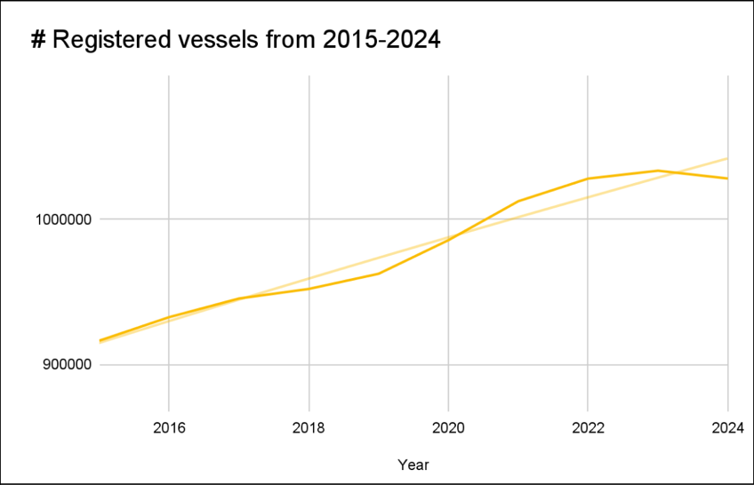
Figure 1: Registered vessel numbers increased in Florida from 2015–2024. Line graph showing the total number of registered vessels in Florida from 2015 to 2024. Data were obtained from annual Florida Fish and Wildlife Conservation Commission (FWC) boating statistical reports and compiled to illustrate long-term trends in vessel registrations.

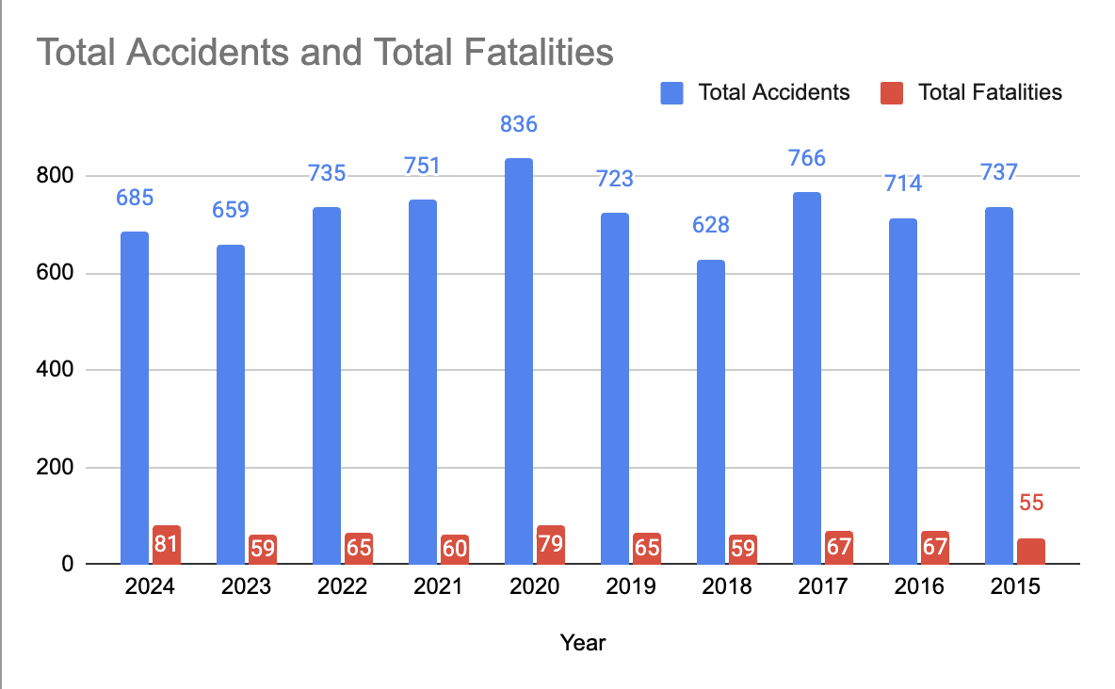
Figure 2: Boating-related fatalities increased despite fluctuations in annual boating accident frequency from 2015–2024. Bar graph showing the annual number of reported boating accidents and boating-related fatalities in Florida from 2015–2024 using Florida Fish and Wildlife Conservation Commission (FWC) annual statistical reports. Annual accident counts ranged from 628 accidents in 2018 to a peak of 836 accidents in 2020, while fatalities generally increased over the study period, reaching a high of 81 fatalities in 2024.

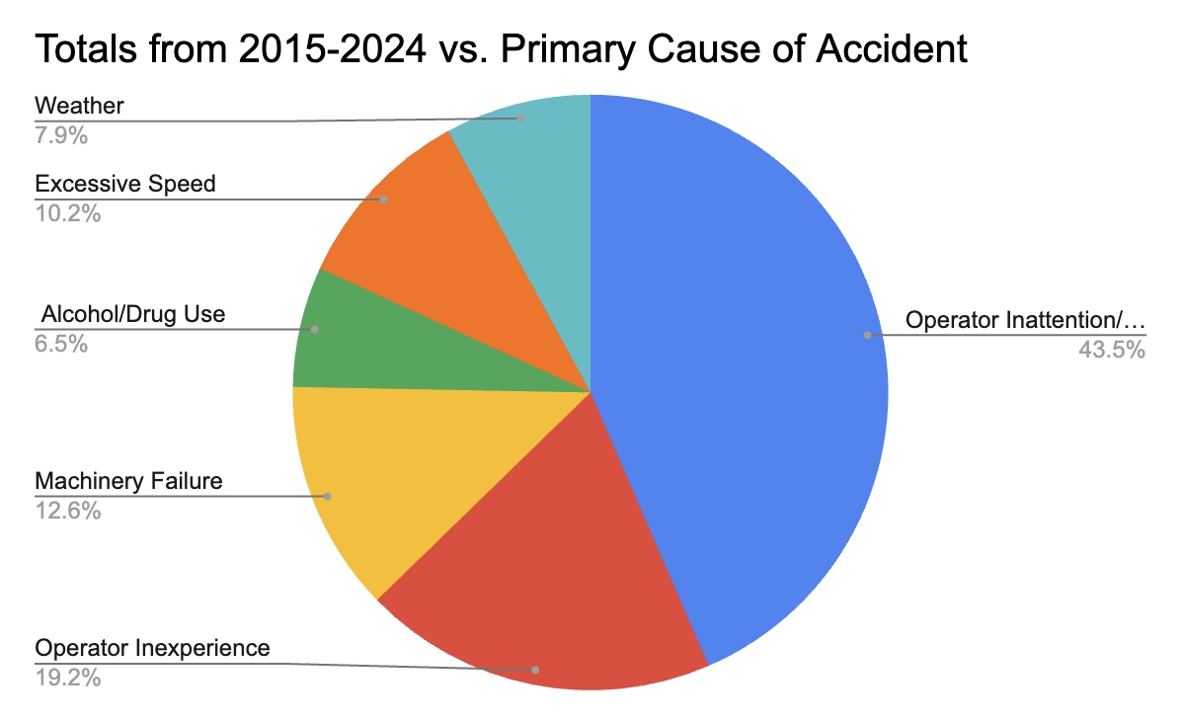
Figure 3: Operator inattention represented the leading contributing factor in Florida boating accidents from 2015–2024. Pie chart showing the proportion of primary accident causes reported by the Florida Fish and Wildlife Conservation Commission (FWC) between 2015 and 2024. Percentages represent the share of total accidents attributed to each contributing factor.

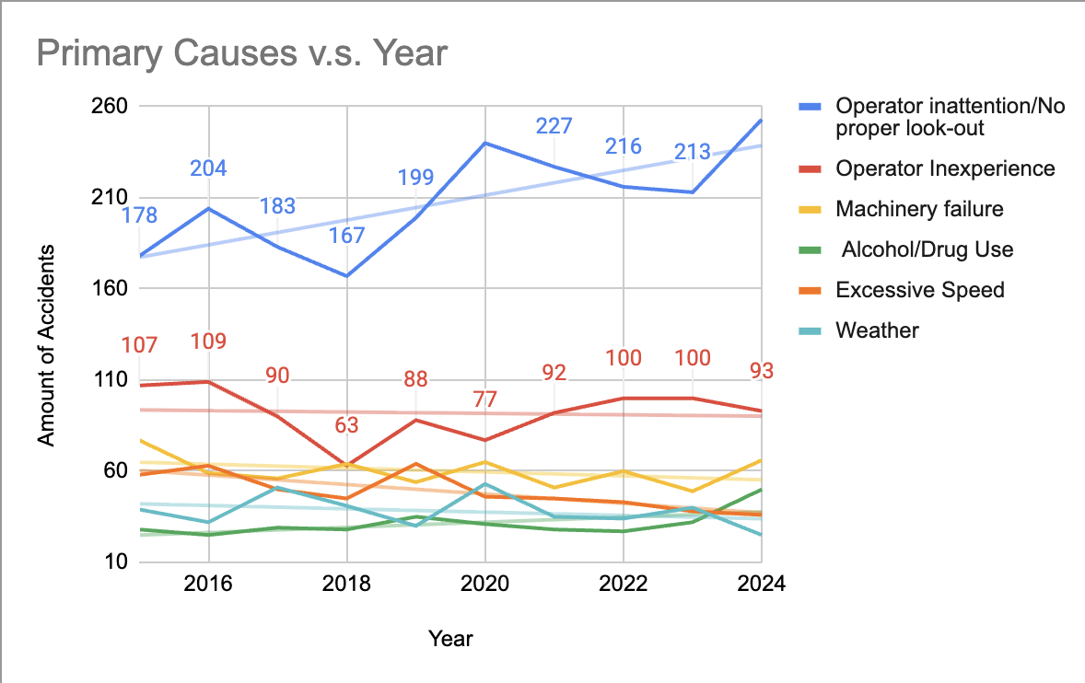
Figure 4: Operator inattention remained the leading contributing factor in Florida boating accidents from 2015–2024. Line graph showing annual trends in the six most commonly reported primary contributing factors in Florida boating accidents: operator inattention or failure to maintain a proper look-out, operator inexperience, machinery failure, alcohol or drug use, excessive speed, and weather. Data were compiled from Florida Fish and Wildlife Conservation Commission (FWC) annual statistical reports from 2015–2024.

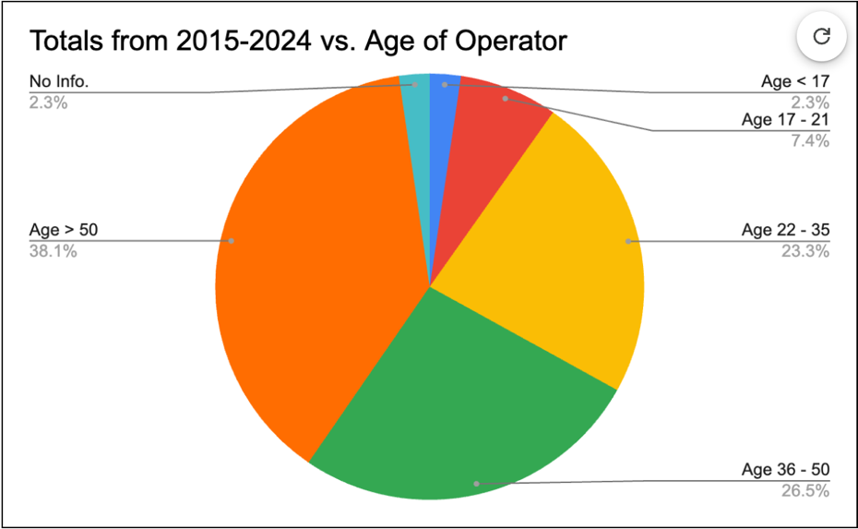
Figure 5: Operators over 50 years of age represented the largest proportion of accident-involved operators from 2015–2024. Pie chart showing the distribution of operator age groups involved in Florida boating accidents using FWC accident data collected between 2015 and 2024.

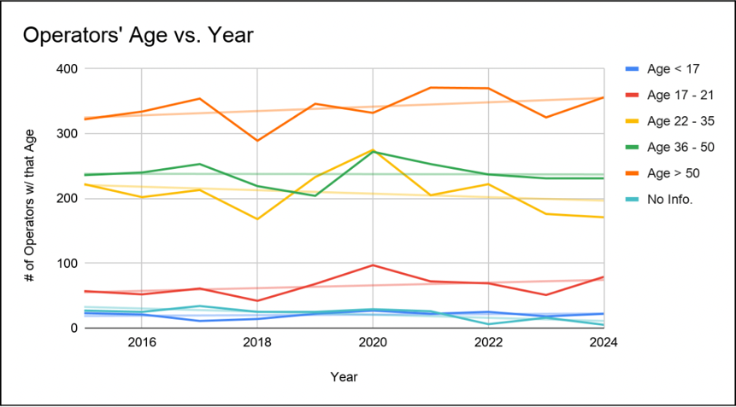
Figure 6: Operators over 50 consistently accounted for more boating accidents than other age groups over the study period. Line graph showing annual trends in accident involvement by operator age from 2015–2024 using data from FWC boating accident reports.

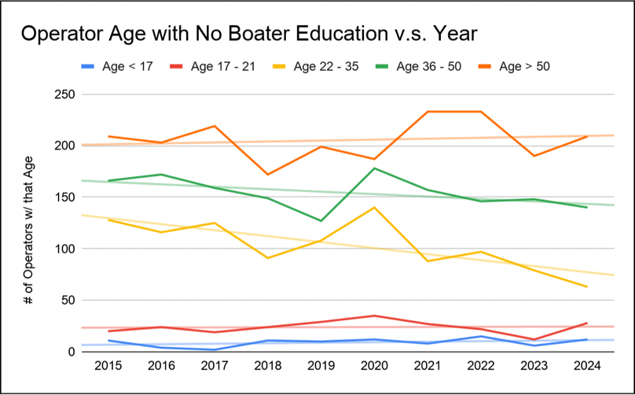
Figure 7: Operators over 50 accounted for the highest number of accident-involved operators without formal boater education. Line graph showing the number of operators with no reported boater education by age group from 2015–2024 using FWC boating accident data.
TABLE WITH TITLES/CAPTIONS
Accident Cause | Definition
Operator Inattention/No Proper Look-Out | No proper watch, the failure of the operator to perceive danger because no one was serving as look-out, or the person so serving failed in that regard.
Operator Inexperience | Refers to a failure to safely navigate or handle a vessel due to limited, insufficient, or lack of experience with that specific vessel, the operating area, or changing weather conditions.
Machinery Failure | Refers to the malfunction of a vessel's mechanical parts or systems which directly leads to a reportable accident.
Alcohol/Drug Use | Refers to any accidents in which alcohol/drug use may have been a contributing factor, whether legally impaired or not.
Excessive Speed | Operating at a speed possibly below the posted speed limit, above that which a reasonable and prudent person would operate under the circumstances.
Weather | Refers to incidents where environmental factors—such as storms, high winds, rough seas, and poor visibility—are determined to be the leading factor causing a collision, capsizing, sinking, or personal injury.

Table 1: Definitions of the different accident causes as defined by the Florida Fish and Wildlife Conservation Commission, 2024. This table highlights that many of the leading causes of boating accidents stem from preventable operator behaviors rather than environmental conditions.

